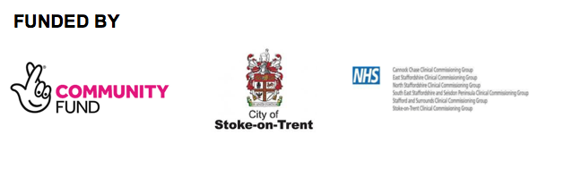
Adult Referral Form

Referrer Details
Referred by Self/Organisation & Address |  | Telephone No.
Has the Carer given permission to share |  | Date

Carers Details
Name Address & Postcode |  | Gender | Male  Female
Telephone No. |  | Date of Birth
Local Authority the carers council tax is paid to |  | Ethnicity
Medical Conditions |  | GP Surgery

Cared for details
Name
Relationship to Carer
Medical Conditions

Local Authority the cared for council tax is paid to

Overview of the Case Background (please give further details of your caring role and what support is needed)

Support Needed
One to One Support |  | Carers Groups
Information Only |  | Carers Wellbeing
Emotional Support |  | Other

Permission to Share Information
For us to help you with your referral we need to record details of your case. These details contain your personal and sensitive data such as address and contact details. To comply with the Data Protection Act (2018) we must tell you how we use this data and ask for your permission. By signing this form, you are providing your permission for us to process your data.

Any information you share with us will be kept safe and secure and processed in line with the Data Protection Act 2018 and our privacy policy. This can be seen on our website www.carersfirst.com or you can request a copy from us by calling NSC on 01782 793100

Everything you tell us will be treated confidentially, however, if a safeguarding risk is identified this will be shared with the Local Safeguarding Board and/or Social Care i.e. if you disclose to us that there is a significant risk of harm to you or another person. In dealing with your case we may also like to refer you into other organisations for additional support, a third party contact will only be made if it relates to your case and with your permission. We may require a separate consent to act on your behalf, if this is needed.
Please note: Nsc is commissioned to deliver the All Age Carers Support Service by Stoke City Council and the Clinical Commissioning Group (CCG), and that all data is owned by them for the life of the contract. They will be able to attain all records that we hold consent for. Any consent that is not given will require us to remove you from the system and stop our support.

I agree/disagree for my information to be shared with the person for whom I care | Agree |  | Disagree
I agree/disagree for my information to be shared with any third party organisation/person who will provide services for me | Agree |  | Disagree

Carers/Professionals Agreement
I confirm that I have been fully involved in the completion of this form and that this accurately reflect issues discussed.

I understand that this document contains a summary of support needs and that it is not a commitment to provide services.
Carers/Professionals Signature |  | Date

For professional use only
Are there any known risks our support staff should be aware of prior to visiting this Carer?

Yes No Please circle or highlight

Comments

Please return the completed form to :
North Staffs Carers, Trent House, 234 Victoria Road,
Stoke-on-Trent, ST4 2LW Tel : 01782 793100 Email : nscreferrals@carersfirst.com

