
Workforce Race Equality Standard (WRES) 2026 Data Analysis

Key Findings:

White colleagues are 10% more likely than global majority colleagues to report that the trust offers fair opportunities for career progression / promotion.
27.2% of global majority colleagues have experienced abuse from patients and the public in the last 12 months compared to 22.6% of white colleagues
30.9% of our workforce are from Black, Asian or Minority Ethnic backgrounds, an increase of more than 17% over the past 10 years

No difference in the likelihood of global majority employees entering the formal disciplinary process compared to white colleagues
3.4% deterioration in global majority colleagues reporting bullying and abuse from other colleagues in the last 12 months (29.35%)
White applicants are 1.9 times more likely to be appointed from shortlisting compared to global majority applicants

18.8% of the UHNM Board are Black, Asian and Minority Ethnic; representing a -13% gap between the board with the composition of the overall workforce
Global majority colleagues are unequally distributed across professional groups:
11.3% are in non-clinical roles, 29.6% in clinical roles and 67.2% in Medical and Dental roles
Global majority colleagues more likely to feel discriminated against by a colleague /manager/team leader at 19.6% compared to 7.7% of white staff

WRES Indicator 1

Percentage representation by ethnicity
At 31st March 2026, Black, Asian and Minority Ethnic colleagues represented 30.9% of our overall workforce, or 4,162 colleagues (+303 people from 2025)
Across the NHS, 30.7% of the workforce are from global majority heritage (WRES Report 2025).

Percentage representation of Black, Asian and Minority Ethnic colleagues in Agenda for Change non-clinical pay bands:

Global majority representation in non-clinical roles has increased year on year since 2021 and is now in line with local community representation within Staffordshire and Stoke on Trent.

The greatest representation is at Band 2, followed by Band 8A, Band 7 and Band 3.

Across the NHS, 20.7% of non-clinical workforce is from Black, Asian and minority ethnic backgrounds. (2025 WRES Annual Report)

Ethnically diverse representation in non-clinical roles has increased by 1.6% (+ 50 headcount) with increased representation in all AfC Bands 2 to 7.

Ethnically diverse representation at UHNM in non-clinical roles is below the representation within our local communities, but there has been positive increases in the last 4 years, suggesting that the widening participation strategy is having impact.

Black, Asian & Minority Ethnic % representation in non-clinical roles trend:

The percentage representation of global majority colleagues in senior non-clinical roles 8C and above, remains an area requiring improvement.

Percentage representation by ethnicity in Agenda for Change clinical pay bands:

Global majority representation has improved year on year in clinical pay bands, doubling in the last six years. International recruitment has influenced representation, particularly at Band 5.

Representation above AfC Band 5 reduces notably, but there has been positive improvement in Bands 6, 7 and 8a over the past 12 months, which is also evidenced in the improved race disparity ratio for middle to upper and lower to upper representation.

Nationally, representation in clinical Agenda for Change Bands is 31.5%. Representation is greatest in bands up to Band 4 (30.0%) and Bands 5-7 (33.8%), and above Band 5 falls dramatically to 18.3% at Band 8a-b.

Percentage representation by Ethnicity in Medical & Dental Grades:

Nationally, at 31st March 2025, 50.0% of NHS doctors/dentists were from Black, Asian and Minority Ethnic backgrounds.

The representation at UHNM is 67%, with the highest representation of global majority colleagues being in non-consultant career grade roles.

WRES Indicator 2
Relative likelihood of white applicants being appointed from shortlisting across all posts compared to Black, Asian & Minority Ethnic applicants

White applicants are almost 1.9 times more likely to be appointed from shortlisting compared to global majority applicants. The National WRES Data Analysis Report (2025) showed that the national likelihood metric was 1.77.

Race Disparity Ratio

The race disparity ratio is a metric that compares the proportion of global majority employees at different pay levels (lower, middle and upper bands) to that of white employees. A ratio greater than 1.0 indicates inequality, suggesting that white colleagues have a higher likelihood of progression than ethnically diverse staff, while a ratio of 1.0 indicates parity.

Across all stages of career progression, global majority colleagues are less likely than white colleagues to progress. While some variation may be influenced by patterns of international recruitment into specific clinical roles and pay bands, the data nevertheless indicates persistent inequalities in progression opportunities.

Positively the data demonstrates better than the national average likelihood of progression for both clinical and non-clinical global majority colleagues progression from middle tier (bands 6-7) to upper tier (8A+).

Agenda for Change Bands | National 2025 | UHNM 2026
Disparity ratio - lower to middle  Clinical  Non Clinical | 0.83  1.00 | 2.45  1.50
Disparity ratio - middle to upper  Clinical  Non Clinical | 2.35  1.27 | 1.72  1.23
Disparity ratio - lower to upper  Clinical  Non Clinical | 2.54  1.71 | 4.21  1.85

The charts below demonstrate the trend in ethnicity representation within Agenda for Change roles at UHNM:

Overall, the organisation has made positive progress in increasing ethnic diversity across Bands 2-8b, particularly within Bands 5-7. However, representation of BAME staff in senior leadership roles (Bands 8c-VSM) remains low, highlighting the need for targeted action to improve progression, talent development and representation at the highest levels of the organisation.

Progress against our Model Employer Aspirational Targets for Black, Asian and Minority Ethnic representation in senior leadership roles (below) also reflects this; with a continued positive trajectory at Band 8a, but below the aspirational targets allocated by NHS England for higher pay bands:

AfC Band | UHNM Headcount 2026 | Model Employer Target 2026
8a | 68 | 45
8b | 6 | 12
8c | 2 | 5
8d | 0 | 3
9 | 0 | 1
VSM | 1 | 1

Ethnicity Pay Gap

Ethnicity pay gap reporting was introduced as part of the EDI Improvement Plan, and our data shows that there is a positive pay gap in favour of global majority employees:

Ethnicity Pay Gap – White : Black, Asian & Minority Ethnic:

 | 2026 | 2025 | 2024 | 2023
Mean pay gap | -24.5% | -22.9% | -25.3% | -29.0%
Median pay gap | -14.5% | -14.3% | -18.4% | -20.4%

This is because there is a greater proportion of global majority employees employed in the middle and upper pay quartiles (quartiles 3 and 4), particularly Asian colleagues. Global Majority representation has increased in all quartiles compared to the previous year:

 | Headcount |  |  |  |  |  |  | % Global Majority representation
Quartile | Asian | Black | Mixed | Not Stated | Other | White British | White Other | % Global Majority representation
1 | 363 | 108 | 53 | 43 | 25 | 2,516 | 109 | 17.1%
2 | 678 | 211 | 59 | 51 | 41 | 2,062 | 116 | 30.7%
3 | 813 | 211 | 52 | 79 | 60 | 1,804 | 140 | 36.0%
4 | 912 | 182 | 75 | 73 | 94 | 1,778 | 162 | 38.6%

WRES Indicator 3
Relative likelihood of Black, Asian & Minority Ethnic staff entering the formal disciplinary process compared to white staff:

Global majority colleagues do not have an increased likelihood of entering formal disciplinary processes at UHNM. Nationally, the 2025 WRES Data Report showed nationally, Black, Asian and Minority Ethnic staff were1.11 times more likely than white staff to enter the formal disciplinary process.

WRES Indicator 4
Relative likelihood of white staff compared to Black, Asian and Minority Ethnic staff accessing non-mandatory training and CPD

The acceptable range for this indicator is between 0.80 and 1.25. Our data has consistently been within this. The national figure in 2025 was 1.02.

WRES Indicator 5
Percentage of staff experiencing harassment, bullying or abuse from patients / service users, their relatives, or the public in the last 12 months (national staff survey q14a):

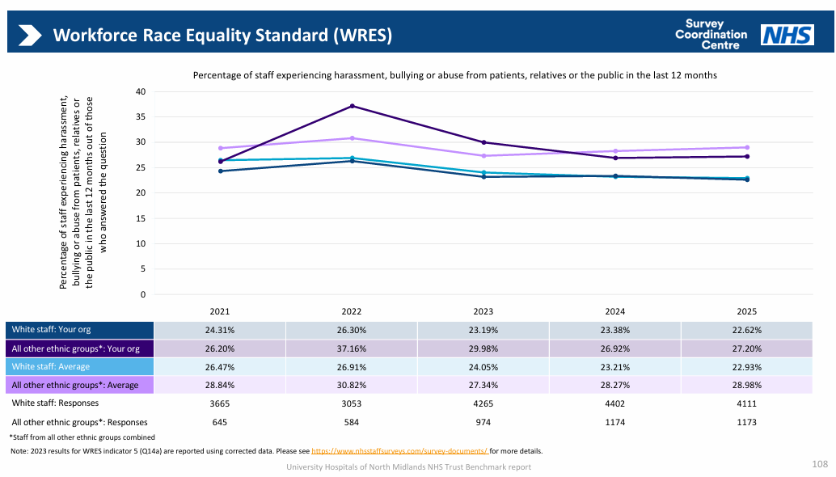
This indicator has deteriorated by 0.28% for global majority colleagues after two years of significant improvement, however it remains better than the peer average, There has been a small improvement for white colleagues.

WRES Indicator 6

Percentage of staff experiencing harassment, bullying or abuse from staff in the last 12 months (national staff survey q14c)

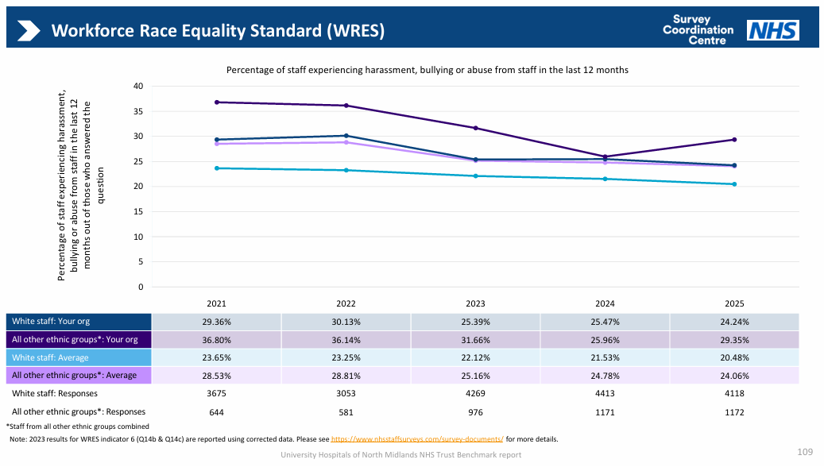
This indicator has deteriorated by 3.39% and is notably worse than the peer average for global majority
staff. White colleague experience has slightly improved, but is also worse than the peer average.

WRES Indicator 7
Percentage of staff believing that their trust provides equal opportunities for career progression or promotion (staff survey q15)

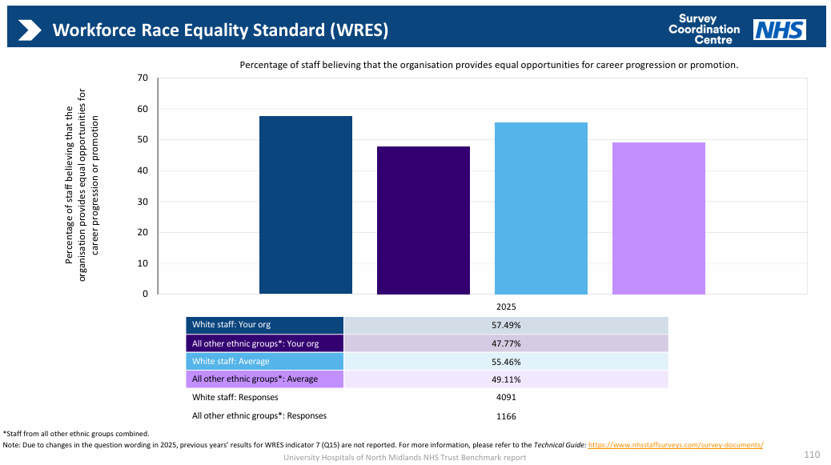
The wording of this question was changed for the 2025 national staff survey. The disparity between white colleague and global majority colleagues remains approximately 10%.
A lower percentage of Black, Asian and Minority Ethnic colleagues (41.31%) than white colleagues (59.86%) felt that the Trust provides equal opportunities for career progression or promotion.

This represents a deterioration in this indicator of 0.51% and the gap between BAME and white colleagues has widened by 2% compared to the previous year. This is also 7.3% worse than our NSS peer comparator group average for Black, Asian and Minority Ethnic colleagues.

The 2023 national WRES Data Report shows that a lower percentage of Black, Asian and Minority Ethnic staff (46.4%) felt that their trust provides equal opportunities for career progression or promotion compared to white colleagues (59.1%).

WRES Indicator 8
Percentage of staff experiencing discrimination at work from other staff in the last 12 months (staff survey q16b)

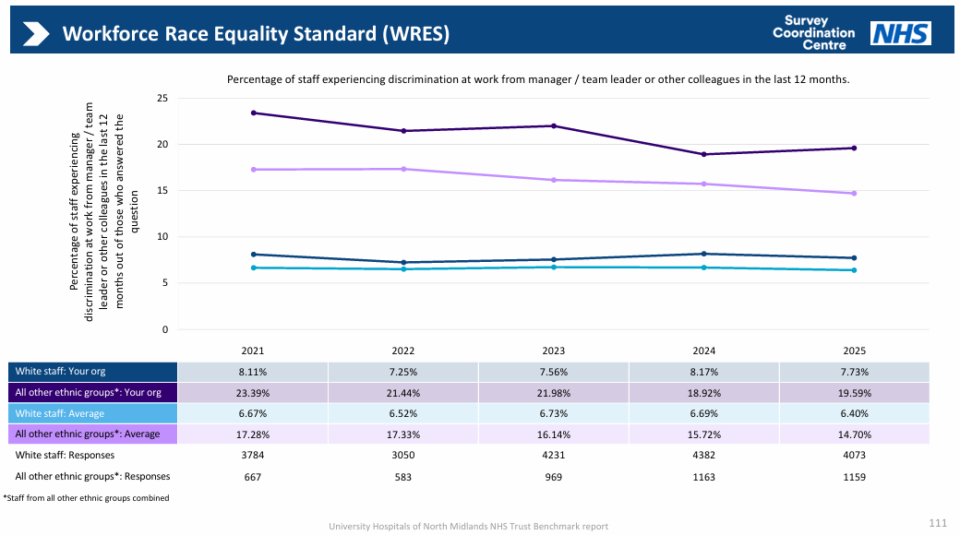
This metric has also slightly deteriorated for global majority colleagues. Both white and global majority colleague experiences are worse than our peer average.

WRES Indicator 9
Representation amongst board members by ethnicity compared to the workforce overall

This indicator measures the difference between the ethnicity composition of our Board membership compared to the overall organisation. Boards are expected to be broadly representative of their workforce. At UHNM, 18.8% of the board are from Black, Asian and Minority Ethnic backgrounds, resulting in a difference between the total board membership and the overall organisation of -12.0%.

Nationally, in March 2025, 17.3% of board members recorded their ethnicity as Black, Asian or Minority Ethnic, resulting in a –13.4% difference with the overall NHS workforce.

Summary and Actions

The findings presented within this report demonstrate that racial inequalities continue to affect the experiences and opportunities of our Global Majority colleagues and prospective workforce. The Mann Review, together with the NHS's commitment to advancing anti-racism, has brought renewed focus to the reality that progress to date has not been sufficient to eliminate inequity in our own organisation and across the NHS. These findings reinforce the importance of sustained leadership, robust accountability and targeted action to deliver measurable improvements across the organisation.

Therefore, we will be establishing a formal Anti-Racism Steering Group to provide strategic leadership, governance and accountability for the Trust's anti-racism agenda. Building on the foundations established by the Race Equality Task and Finish Group, the Steering Group will oversee implementation of the Mann Review recommendations and our monitor performance and outcomes, ensure alignment of our task and finish groups with NHS anti-racism standards, and provide regular assurance on progress and impact to executive and Board-level committees.

We will work in partnership with our Ethnic Diversity Network to provide insight, challenge and feedback on the effectiveness of our equality initiatives, helping us understand whether our actions are leading to meaningful improvements in the lived experiences, opportunities and outcomes of ethnic minority colleagues.

