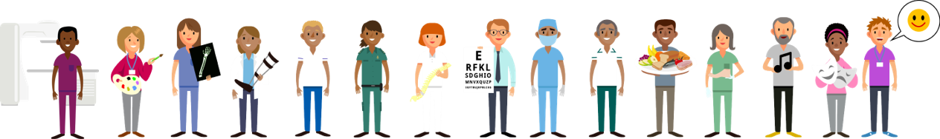

Allied Health Professionals Day 14th October 2023
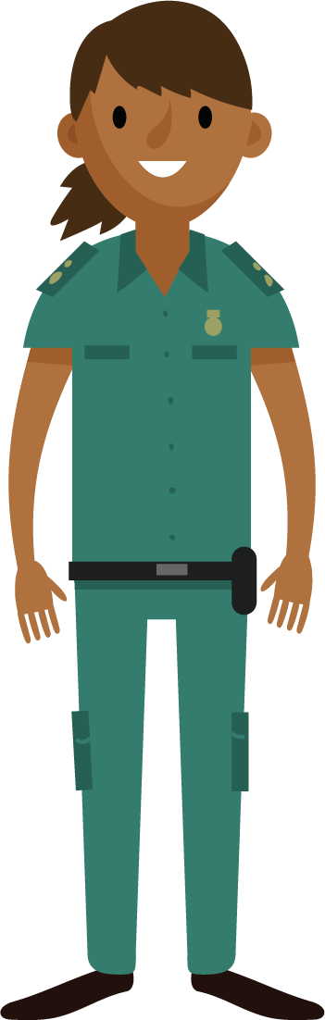
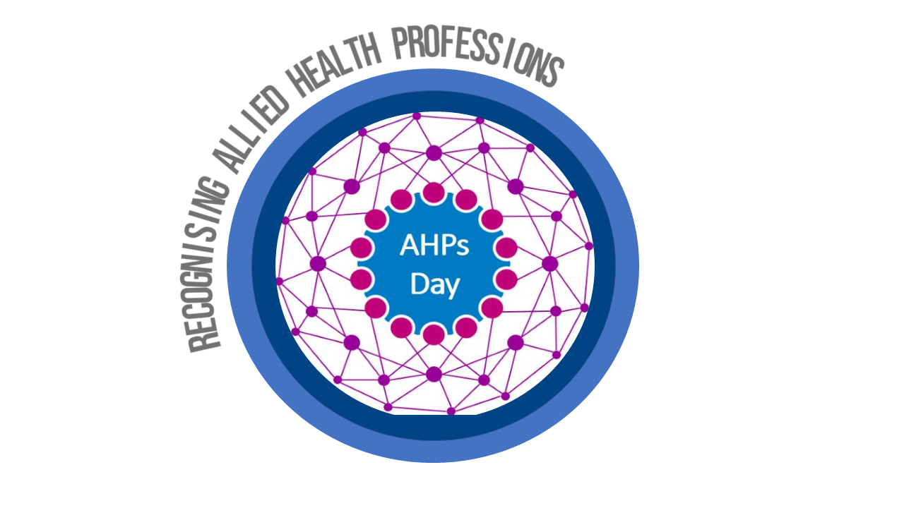

Hello…..I am a Paramedic

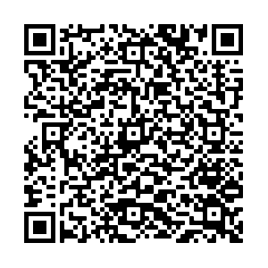

Find out more by
scanning the QR code

