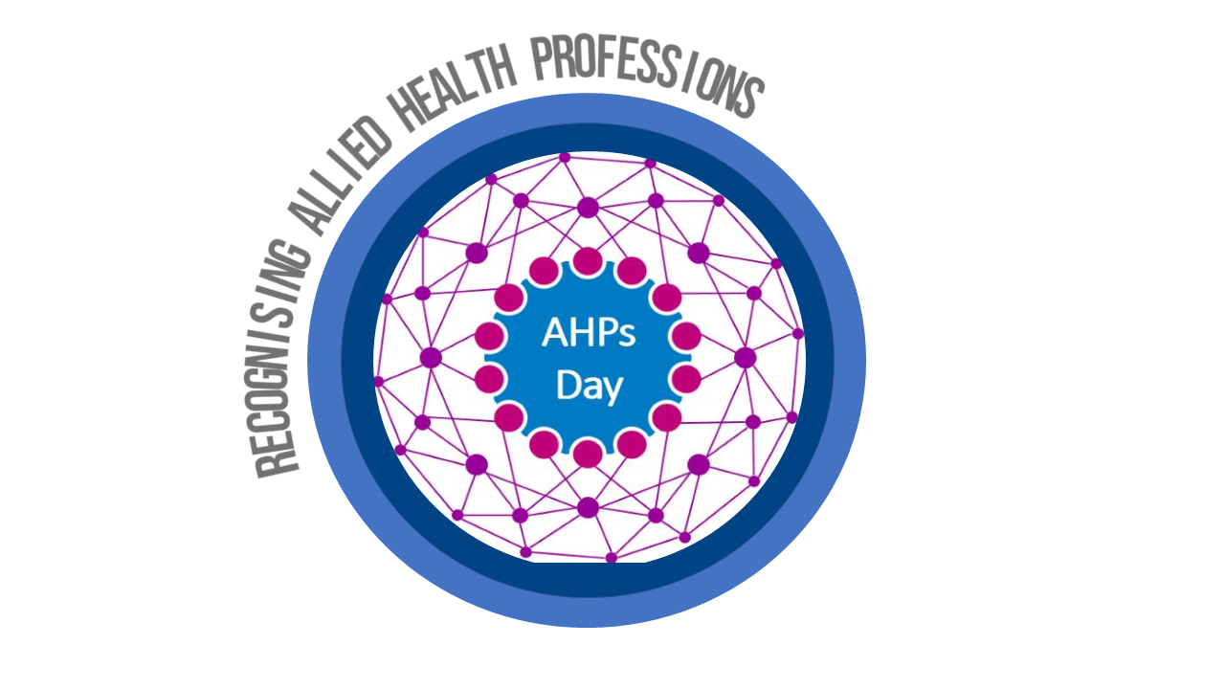
Allied Health Professionals Day 14th October 2023

Hello…..I am an Operating
Department Practitioner

Find out more by
scanning the QR code

