

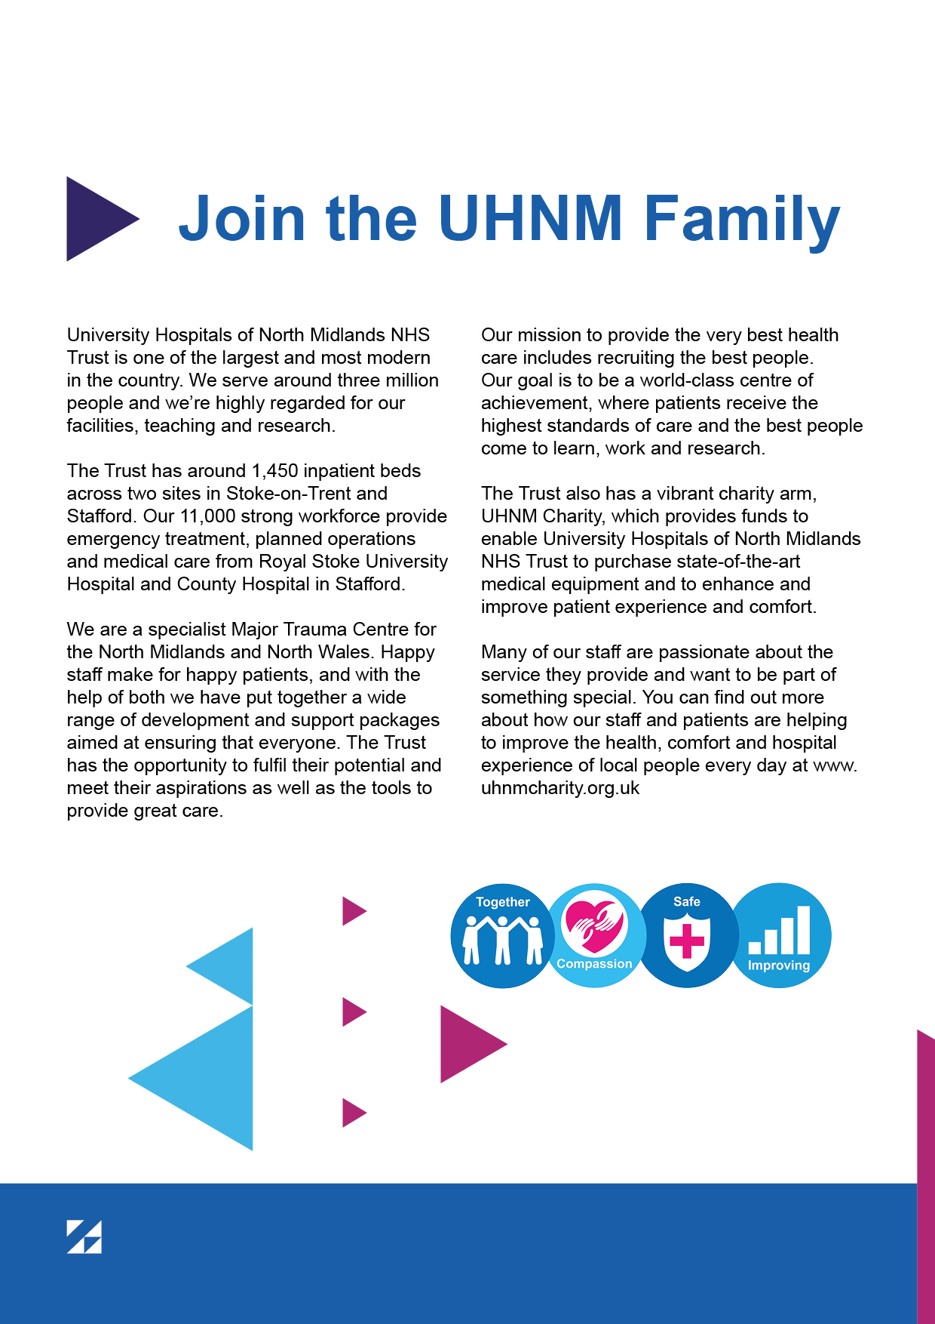
Values & Promises

We have four core values and promises that were co-created by our staff, patients and carers.

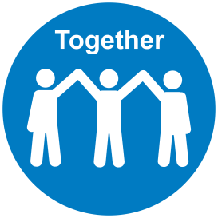
Together
- We are a Team – I will be considerate, help others to achieve our goals and support others to make positive changes
- We are Appreciative – I will acknowledge and thank people for their efforts and contributions
- We are Inclusive – I will be open and honest, welcome people’s views and opinions and involve people in decisions that affect them


Compassion
- We are Supportive – I will be empathetic and reassuring. I will support and encourage people when they need it
- We are Respectful – I will treat people fairly, with respect and dignity, protect their privacy and help them to feel comfortable
- We are Friendly – I will be welcoming and approachable. I will make eye contact, say hello and introduce myself #hellomyname is


Safe
- We Communicate Well – I will explain clearly, share relevant and timely information and keep people updated
- We are Organised – I will plan ahead, manage my time well and be prompt in what I do
- We Speak Up – I will contribute to ensuring healthy and constructive feedback for all so we can feel safe to challenge inappropriate care and behaviour and promote our values

Improving

- We Listen – I will welcome people’s views and ideas, invite people to ask questions and share their opinions and respond to what I hear
- We Learn – I will share best practice, celebrate good performance and support others to use their skills, learn and grow
- We Take Responsibility – I will have a positive attitude, act and encourage people to take the initiative and make improvements

Division: Therapies

Job Title: Advanced Physiotherapist

Band: 7

Location: Royal Stoke/County

Hours: 37.5

Managerially accountable to: Divisional Therapy Managers, Principal Therapists

Professionally accountable to: Divisional Therapy Managers, Therapy Team & All members of the multi-disciplinary team patients, relatives and Carers

Role Summary

This role works autonomously as a specialised practitioner managing the clinical delivery of care within a specialised area. The Advanced Therapists lead the clinical team within your specialised area and organise staff and resources to meet service standards and workload demands.
This post treats patients that include the critically ill, unconscious, unstable, neurological, acute and chronic respiratory, multi pathology / complex patients, cognitively and perceptually impaired

Key Areas/Tasks

- To work as part of the multi-disciplinary team providing therapy input to patients in your specialised area and to liaise with other disciplines and agencies as required in the planning and implementation of patient care
- To educate patients and their relatives / carers about their condition and its significance and ensure that care information and support is available.
- To use negotiating and persuasive skills to facilitate effective service delivery within the specialty team and Department
- To support and liaise with the Principal Therapists and Divisional Therapy Managers.
- To maintain lines of communication within the Therapies Department
- To actively participate in ward meetings, ward rounds, case conferences as appropriate.
- To liaise with and work as an integral member of the multi-disciplinary team, building and maintaining effective working relationships within the Trust and the health economy.
- To use motivational and negotiation skills in the treatment of patients in your specialised area to gain consent and compliance with treatment where patients have significant barriers to communication e.g. dementia, cognitive impairment, behavioural problems, low awareness state.
- To communicate and process complex and sensitive information to and from patients, carers and multi-disciplinary team.
- To represent the Therapies Department e.g. meetings, projects, as agreed with the Principal Therapists or Divisional Therapy Managers.
- Liaise with other agency service providers (including GP’s, Clinics, Community / Outpatients Service, Intermediate Care Team, Equipment Loan Stores, Discharge Team).
- Committed to working at Masters Level or courses accredited at Master Level
- To act as a source of expert knowledge and to give advice to other staff as appropriate.
- Musculoskeletal Team – post-holder will rotate within the team
- To increase awareness and profile of the profession by undertaking presentations, in-service training and other public relations exercises.
- To be responsible for the provision of specialist training to therapy staff and other members of the multi-disciplinary team.
- As an experienced practitioner use analytical and problem solving skills to interpret, analyse and evaluate complex information from a variety of sources e.g. medical notes, diagnostic tests and clinical investigations
- To assist the delivery of an integrated Therapy Service within the Department.
- To lead the clinical team within your specialised area, providing clinical supervision, organising staff and resources to meet service standards and workload demands, dealing with sickness absence, recruiting staff, allocating work and monitoring, and performance management.
- To provide cover for other teams within the Directorate based on your knowledge, skills and competencies in order to meet changing priorities and service demands.
- To maintain an appropriate caseload offering specialist assessment, including interpretation of diagnostic test contributing to diagnosis, management and education of patients
- To plan, implement and evaluate specialist treatment plans for patients who may have complex needs including physiological, psychological and social factors, reviewing and adapting treatment plans to suit the patients’ individual needs.
- To use manual handling techniques in the rehabilitation of patients working within Trust, Directorate and professional policies, guidelines and protocols.
- To use manual physiotherapy techniques which may be repetitive in nature and, may require a level of precision and dexterity.
- To carry out specialised procedures / techniques this may /may not involve use of equipment.
- To undertake emergency on call (physiotherapy only) and/or bank holiday/weekend work across 2 Trust sites including working unsociable hours and lone working.
- To ensure that suitable equipment and materials are selected and properly used and that staff, patients and carers are appropriately trained
- To work to the relevant Professional Code of Ethics and Professional Code of Conduct.
- To work towards national and locally agreed standards of service.
- To adhere to University Hospital of North Midlands NHS Trust and the Therapy Department policies, procedures and guidelines.
- To contribute to the clinical governance strategy and integrate service standards and operational procedures.
- To give advice to staff regarding departmental procedures and protocols, staff performance and maintenance of professional standards with both qualified and support staff.
- To participate in the development of Trust, health economy, regional and national guidelines, interdisciplinary pathways and policies.
- To contribute to service development in liaison with the Divisional Therapy Managers
- To participate in the development and implementation of quality initiatives including standards of patient care, protocols, guidelines, clinical audit and monitoring of service provision in collaboration with colleagues and service users within the remit of the post
- To be flexible and adapt to the changing needs of the Therapies Department.
- To assist in the development of the Therapies Department Business Plans.
- To work with Team Leader on management projects as requested, contributing to the operational management agenda.
- To take a lead role in the responsibility for stock control, requisitioning of equipment / materials.
- To ensure that financial procedures and arrangements are adhered to, so that financial management targets are met.
- To support the Team Leader in the implementation of systems for clinical governance including the resolution of complaints and adverse incidents.
- To access and input to manual and electronic information systems.
- To keep accurate and up to date patient records, documentation and statistical information following local and national guidelines.
- To support in the collation of performance figures for the Divisional Therapy Managers to enable service level agreements to be monitored.
- To compile reports / document as required e.g. clinical audit, collating information from a number of sources.
- To identify and lead audit projects within the Department and participate in research.
- To implement and to encourage staff to use evidence-based practice, appraisal of literature and journal clubs.
- To disseminate audit / research findings at multi-disciplinary conferences, via multidisciplinary publications in order to share best practice, locally, regionally, nationally and internationally.
- To delegate appropriately to qualified and unqualified staff
- To work as an autonomous practitioner in the clinical setting
- To move and handle equipment on a daily basis e.g. hoists, wheelchairs, assistive equipment (e.g. walking aids, toilet seats)
- To carry a bleep and to change from one activity to another at short notice e.g. to manage staff issues, meet changing clinical or work demands,
- To concentrate for up to 1-2 hours at a time through the shift whilst reading, interpreting and analysing patients notes, preparing reports, carrying out assessments and treatments and when documenting treatment interventions, outcomes, analyses and plans.
- To respond appropriately in an emergency situation in case of cardiac / respiratory arrest or acute deterioration of a patient’s condition during therapy intervention
- To respond immediately to any acute respiratory deterioration as an emergency call on a regular basis.
- To give consideration to and manage the emotional and psychological requirements of patients (and their carers) who have a chronic, acute or terminal diagnosis or who are going through a bereavement following e.g. loss of a limb or functional ability.
- To deliver unwelcome or hard to accept information to patients and carers, for example, relating to limited rehabilitation outcomes and inability to return to previous home environment.
- To provide emotional support to staff within a specialty where there are high levels of emotional stress when treating patients with severe disability, terminal illness, who are critically ill and to individuals receiving bad news.
- To undertake work on wards or in the patient’s home environment as necessary with due regard to the issues potentially compromising safe working practice e.g. working in restricted spaces.
- To work in a highly unpleasant environment with frequent daily exposure to body fluids, including sputum, sick, urine and faeces (and dealing with these as appropriate) and occasional exposure to verbal or physical aggression.
- To work routinely in highly challenging, distressing or emotionally charged situation providing treatment to critically ill, deteriorating or terminally ill patients and support others in that environment.
- Managers who have responsibility for supervising/managing people must comply with the guidelines that can be found in the “Code of Conduct for NHS Managers”
- The principles of “Improving Working Lives” must be upheld at all times
- To promote and practice customer care and to act in a manner which presents the good image of the trust
- To contribute to improving standards, performance and efficiency.
- To work to the standards set out in the Data Quality Policy and to promote E&D and H&S standards.

Personal/Professional Development

- To take every reasonable opportunity to maintain and improve your professional knowledge and competence
- To participate in personal objective setting and review, including the creation of a personal development plan and the Trust’s appraisal process.

Health and Safety

- To take reasonable care for your own Health and Safety and that of any other person who may be affected by your acts or omissions at work.

- To co-operate with University Hospitals of North Midlands (NHS) Trust in ensuring that statutory regulations, codes of practice, local policies and departmental health and safety rules are adhered to.

- To comply and adhere to individual and role specific responsibilities as stated in the Trust Health and Safety Policy (HS01) and all other Health and Safety related policies.

Equality and Diversity

UHNM is committed to the implementation of the Equality, Diversity and Inclusion Policy
Which ensures equal opportunities for all. UHNM is also committed to embracing diversity
and eliminating discrimination in both its role as an employer and as a provider of services.
It aims to create a culture that respects and values each other’s differences, promotes
dignity, equality and diversity and encourages individuals to develop and maximise their
potential. All staff are required to observe this policy in their behaviour to other workers and
patients/service users

Infection Prevention

Infection Prevention is the obligation of every employee both clinical and non-clinical at the University Hospitals North Midlands NHS Trust. Driving down healthcare associated infection is everyone’s responsibility and all staff are required to adhere to the Trust’s Infection Prevention policy

All staff employed by the UHNM Trust have the following responsibilities:

Trust Dress Code
- Trust approved uniform/dress code must be adhered to
- When in clinical areas all staff must be bare below the elbow, without wrist watches, stoned rings, wrist jewellery, false nails, nail polish or plaster casts
- No personal bags to be worn during clinical duties

Hand Hygiene
- Decontaminate your hands as the per ‘The five moments of hand hygiene’

Own Practice
- Lead by example
- Encourage and praise good practice
- Be prepared to accept advice about your own practice

Decontamination
- Ensure that equipment you have been using or about to use has been decontaminated effectively
- Ensure that you are aware of the Trust approved cleaning products, and follow a safe system of works

Trust Policies
- Ensure that you know and strictly follow relevant Infection Prevention policies for your role and apply standard precautions at all times, which is available in the Infection Prevention Manual on the UHNM intranet

Data Protection Act, General Data Protection Regulation (GDPR) and the NHS Code of Confidentiality

All staff are responsible for ensuring they are familiar with and adhere to the Trust’s policies, procedures and guidelines with regards to the Data Protection Act, General Data Protection Regulation (GDPR) and the NHS Code of Confidentiality. This includes confidentiality, information security, cyber security, secondary use and management of records.

Staff have a responsibility in protecting the “rights and freedom” of natural persons (i.e. live individuals) and to ensure that personal data is not processed without their knowledge, and, wherever possible, that it is processed with their consent. Processing includes holding, obtaining, recording, using and disclosing of information and applies to all forms of media, including paper and images. It applies to both patient and staff information

Hence staff must ensure confidentiality is maintained at all times, data is recorded accurately and you only access this information as part of your job role

Safeguarding Children, Young People and Adults with care and support needs

All staff are responsible for ensuring that they are familiar with and adhere to the Trusts Safeguarding Children and Adults policies, procedures and guidelines. All health professionals who come into contact with children, parents, adults with care and support needs and carers in the course of their work have a responsibility to safeguard and promote their welfare as directed by the Children Acts 1989/2004 and the Care Act 2014. Health professionals also have a responsibility even when the health professional does not work directly with a child or adult with care and support needs but may be seeing their parent, carer or other significant adult.

All staff are required to attend safeguarding awareness training and undertake any additional training in relation to safeguarding relevant to their role

This job description is not intended to be an exhaustive list and may be subject to change from time to time. All documents referred to throughout this Job Description can be found on the Trust’s intranet, or alternatively copies can be obtained from the Human Resources Directorate

Sustainability


Sustainability and Corporate Social Responsibility are fundamental to the way the University Hospitals of North Midlands NHS Trust (UHNM) work. The Trust has developed a Sustainable Development Management Plan (SDMP): ‘Our 2020 Vision: Our Sustainable Future’ with a vision to become the most sustainable NHS Trust by 2020. In order to achieve this, we need the support of all staff. As a member of staff, it is your responsibility to minimise the Trust’s environmental impact and to ensure that Trust resources are used efficiently with minimum wastage throughout daily activities. This will include minimising waste production through printing and photocopying less, reducing water waste and when waste is produced, it is your responsibility to segregate all clinical waste correctly and recycle. Switch off lights and equipment when not in use, report all faults and heating / cooling concerns promptly to the Estates Helpdesk and where possible minimise business travel. Where the role includes the ordering and use of supplies or equipment the post holder will consider the environmental impact of purchases.

SWITCH to a Sustainable UHNM is a campaign that focuses on the sustainability of the Trust and how we can use resources more effectively to provide better patient care, improve our health and work place. SWITCH is looking to recruit as many Champions as possible to help to bring the campaign to colleagues in their departments / wards and bring SWITCH to life. If you are interested in becoming a SWITCH Champion please contact switch@uhns.nhs.uk

Disruptive Incident & Business Continuity

The Trust needs to be able to plan for, and respond to a wide range of incidents and emergencies that could affect health or patient care. These could be anything from severe weather to an infectious disease outbreak or a major transport accident.

All staff are required to have an awareness of the Trust’s business continuity arrangements, as a minimum. All staff will be required to;
- To know how to identify a business continuity incident and the method for reporting;
- To have an awareness of local business continuity arrangements;
- To participate in awareness, training and exercises, as required;

In the event of a disruptive incident, all Trust employees will be required to attend work if they are fit and well and able to do so in line with a Trust risk assessment Those who are clinically qualified will be required to work flexibly across the Trust to meet the service need in clinical areas. This will include front line clinical staff who will be expected to cover alternative duties as and when required in order to ensure that all essential services are maintained.

Signed Employee ________________ Print ________________ Date ________________

Signed Manager _________________ Print ________________ Date ________________

Advanced Physiotherapist - Person Specification
 | Specification | Criteria |  | Evidence
 | Specification | Essential | Desirable | Evidence
Essential Qualifications | Degree/Diploma in Physiotherapy  Registered with HCPC  Evidence of personal and professional development  Post graduate (NHS) experience with considerable experience in speciality area  Working towards a higher qualification relevant to speciality e.g. Master’s degree |  |  | Application Form/  Interview
Knowledge, Skills, Training and Experience | Experience of working as a Senior Physiotherapist within the speciality area  Experience of teaching students, staff and other professional groups  Trained Clinical Educator  Experience of undertaking out of hours working  Experience of supporting/supervising staff  Ability to liaise with other professionals/agencies  Proven leadership and management skills  Knowledge of audit and research  Knowledge of interdisciplinary working  Articulate, able to undertake presentations and tutorials  Demonstrate critical appraisal skills  Ability to prioritise & manage time  Ability to react well to pressure  Ability to develop different approaches to patient care  Ability to develop credibility rapport and rapport with colleagues  Good communicator – verbally and in writing  Acts to support and enable effective teamwork  Evidence of project work  Experience gained within an acute setting  Involvement in audit/research |  |  | Application Form/  Interview
Personal Qualities | Ability to be flexible and adaptable  Excellent attendance record/reliable  Ability to undertake A&C duties linked to clinical work  Adherence to the Trusts Uniform Policy  Positive mindset in respect of – Supporting organisational change; learning, and continuous improvement.  Takes responsibility and is accountable for delivering to their agree objectives  Consistently professional, collaborative and compassionate in their approach.  Works with patients and people at the fore – operates to a customer service ethos  Emotional effort; the post holder will at times be exposed to distressing and emotional circumstances  Ability to travel to and work across multiple sites |  |  | Application Form/  Interview

