
Workforce Disability Equality Standard (WDES) 2026 Data Analysis
A higher percentage of colleagues with a disability/long term condition (31.2%) than those without a disability/LCT (18.6%) report experiencing discrimination from other staff in the last 12 months
Key Findings:
6.7% of colleagues have shared a disability or Long Term Condition (LTC) on ESR compared to 27.8% in the anonymised 2025 NHS Staff Survey

Colleagues with a disability/LTC are 9% more likely to feel pressure from their manager to come to work, despite not feeling well enough to perform their duties, compared to colleagues without a disability/LTC
51.8% of colleagues with a disability/LTC compared to 58.5% of colleagues without a disability/LTC believe the trust provides equal
opportunities for career
progression or promotion

74% of colleagues with a disability/LTC feel they have had the workplace adjustments they need to do their job

28% of colleagues with a disability/LTC reported experiencing harassment, bullying or abuse at work from patients / service users, their relatives or other members of the public and 29% from other colleagues
Non disabled applicants are 1.01 times more likely to be appointed from shortlisting than applicants with a disability, demonstrating parity

12.2% of Trust Board members have shared that they have a disability/LTC on ESR

Introduction

The WDES comprises of 10 indicators. Six of which are drawn from the most recent annual NHS National Staff Survey. The UHNM response rate for the 2025 staff survey was 41% with 28.95% of respondents stating that they had a physical or mental health condition or illness lasting or expected to last 12 months or more. This compares to the peer average of 24.9% and is our highest ever response rate.


WDES Indicator 1
Percentage Representation of Workforce Disability

6.7% of UHNM colleagues (898 people) have shared that they have a disability on ESR. Yearly trends show significant improvement in declaration rates on ESR with a 23% reduction in ‘unknown’ disability status over the last five years.

The percentage of NHS staff in England working with a disability is also 6.7% with 81.4% not disabled and 11.9% unknown status. (source: 2025 WDES Data Report)

Nationally it is recognised that there is a significant under reporting across the country of the numbers of staff who disclose a disability on ESR, compared to those sharing this information when completing the anonymous NHS Staff Survey. We regularly encourage our workforce to update their ESR record and the number of records where colleagues have not disclosed their disability status has improved significantly from 41% in 2020 to 11.3% in 2026.

Disability representation across clinical and non-clinical groups:
Disability Category (ESR) | %
Long-standing illness | 31.6%
Learning disability/difficulty | 20.1%
Other | 13.1%
Mental Health Condition | 12.0%
Yes (unspecified) | 9.6%
Physical Impairment | 7.5%
Sensory Impairment | 6.1%

‘Long standing illness,’ ‘learning disability/ difficulty’ and ‘mental health conditions’ are the most commonly selected categories.
In the most recent national data available from the 2023 WDES Data report 4.9% of NHS colleagues have declared a disability on the ESR system.
Workforce disability recorded on ESR
The WDES presents workforce data in four Agenda for Change clusters and a Medical & Dental professional group. The percentage of employees with a disability has increased in all pay clusters (apart from 8C and above) compared to the previous three years:

Disability Pay Gap

Disability pay gap reporting has been introduced as part of the EDI Improvement Plan. Our data shows that there is a 13% pay gap between colleagues with a disability compared to those without. This is because the proportion of disabled people employed decreases as the pay quartiles increase.

Disability Pay Gap – No disability : Employees with disability recorded on ESR:

 | 2026 | 2025 | 2024 | 2023
Mean pay gap | 13.5% | 13.9% | 12.5% | 13.0%
Median pay gap | 12.8% | 13.4% | 10.4% | 11.3%

Quartile | Not disabled | Status not known | Disabled | % Disability representation
1 | 2701 | 202 | 321 | 10.0%
2 | 2787 | 220 | 218 | 6.8%
3 | 2822 | 205 | 199 | 6.2%
4 | 2847 | 234 | 144 | 4.5%
Note: the under reporting of disability status on ESR influences the efficacy of disability pay gap reporting.

WDES Indicator 2
Relative likelihood of Disabled applicants being appointed from shortlisting across all posts compared to applicants without a disability
Analysis of recruitment activity recorded on the TRAC recruitment system shows that non-disabled applicants are 1.09 times more likely to be appointed from shortlisting compared to Disabled applicants (a metric of 1.0 represents equal likelihood of disabled and non-disabled applicants being appointed from shortlisting).

A continued downward (positive) trajectory in our recruitment data compares with the most recent national average metric from 2023, which was 0.99.

Analysis of recruitment activity recorded on the TRAC recruitment system shows that non-disabled applicants are 1.01 times more likely to be appointed from shortlisting compared to Disabled applicants (a metric of 1.0 represents equal likelihood of disabled and non-disabled applicants being appointed from shortlisting). A continued downward (positive) trajectory in our recruitment data compares with the most recent national average metric from 2025, which was 0.95.

WDES Indicator 3
Relative likelihood of Disabled staff entering the formal capability process compared to non-disabled staff

This indicator is based on data from a two-year rolling average of entry into a formal capability process for performance reasons as recorded on the Employee Relations Case Tracker.

Our Capability Policy is designed to be supportive and encouraging to enable colleagues to reach the desired performance level through informal processes and hence relatively small numbers of staff enter the formal stage of the policy.

This year’s result gives a relative likelihood of Disabled staff entering the formal capability process compared to non-disabled staff score of 3.5.

WDES Indicator 4a
Percentage of staff experiencing harassment, bullying or abuse from patients/service users, their relatives or the public in the last 12 months

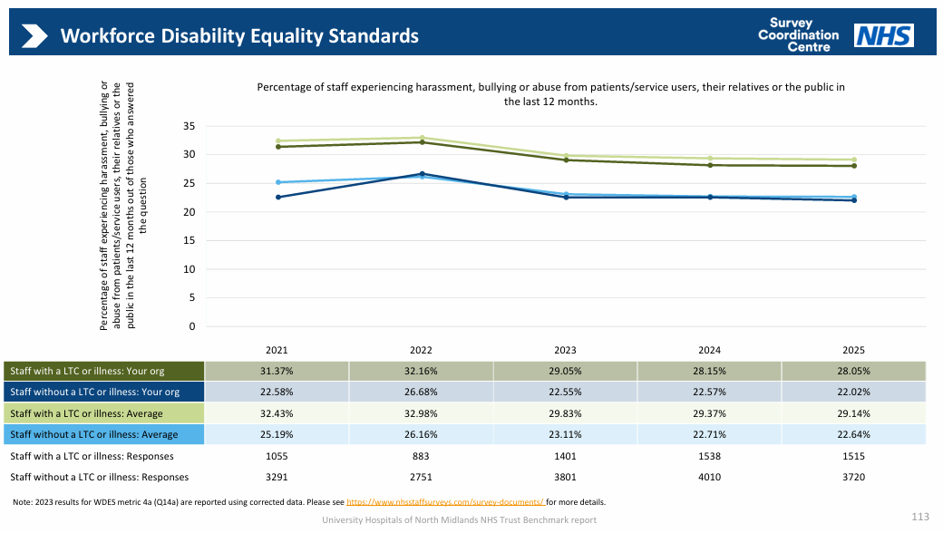
This year’s figure is our best performance for colleagues with a disability/long term condition since we began reporting the WDES and is better than our NSS peer comparator group. The difference compared with non-disabled colleagues has also reduced.

The 2023 National Data Report shows the national indicator of harassment, bullying or abuse from patients/service users, their relatives or the public in the last 12 months is 33.2% for disabled colleagues and 26% for non-disabled colleagues (a difference of 7.2%)

Whilst the levels of abuse experienced by colleagues is unacceptably high, this year’s figure is our best performance for colleagues with a disability/LTC since we began reporting the WDES and is better than our peer comparator group for the second consecutive year.

Nationally 29.6% of disabled colleagues and 23.4% of non-disabled colleagues reported experience of harassment, bullying and abuse from patients/service users, their relatives or public in the previous 12 months. (source: WDES Data Report 2025)

WDES Indicator 4a
Percentage of staff experiencing harassment, bullying or abuse from managers in the last 12 months
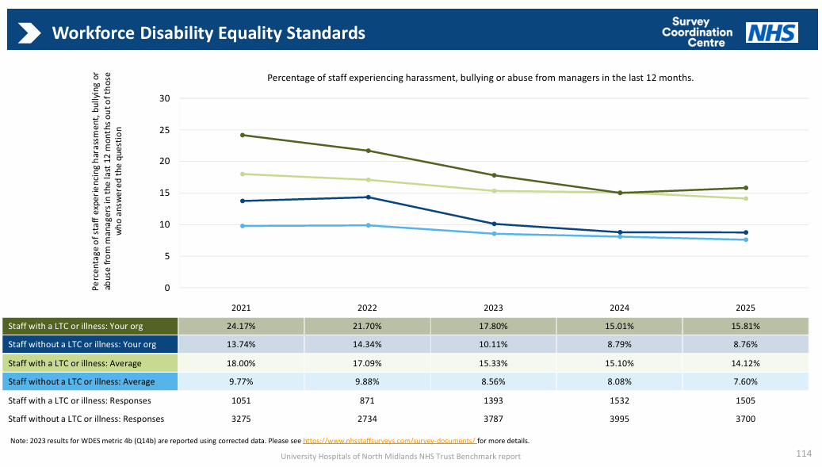

This year’s performance has deteriorated by 0.8% The most recent national data shows that 13.9% of disabled and 7.6% of non-disabled NHS staff reported receiving harassment, bullying or abuse from managers in the previous 12 months.

WDES Indicator 4a
Percentage of staff experiencing harassment, bullying or abuse from other colleagues in the last 12 months

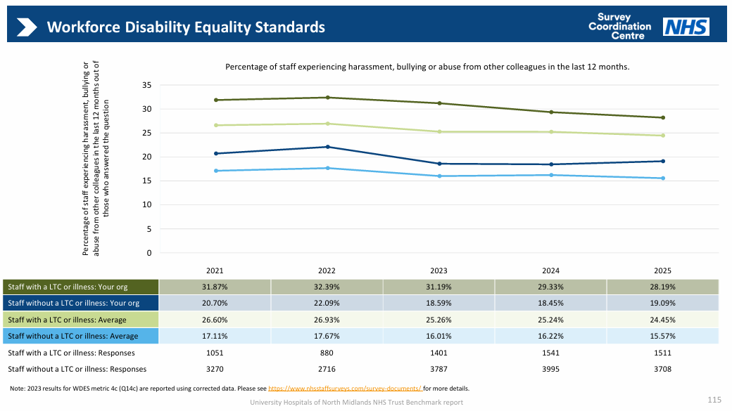
There has been a small improvement in this indicator, but the gap between the experiences of colleagues with a disability/LTC and staff without a disability/LTC has increased. Our performance is worse than our National Staff Survey peer comparator group.

Nationally, the latest data available from the 2023 WDES National Data Report shows that 24.8% of disabled staff in the NHS and 16.5% of non-disabled staff have reported experiencing harassment, bullying or abuse from other colleagues.

There has been an improvement in this indicator of 1.14%, and the gap between the experiences of colleagues with a disability/LTC and staff without is less than 10 percentage points for the first time. Our performance is worse than the National Staff Survey peer comparator group for all colleagues.

The national data from the most recent WDES Report shows that 23.4% of disabled and 15.1% of non-disabled colleagues report experience of harassment bullying or abuse from colleagues in the last 12 months.

WDES Indicator 4b
Percentage of staff saying that the last time they experienced harassment, bullying or abuse at work, they or a colleague reported it

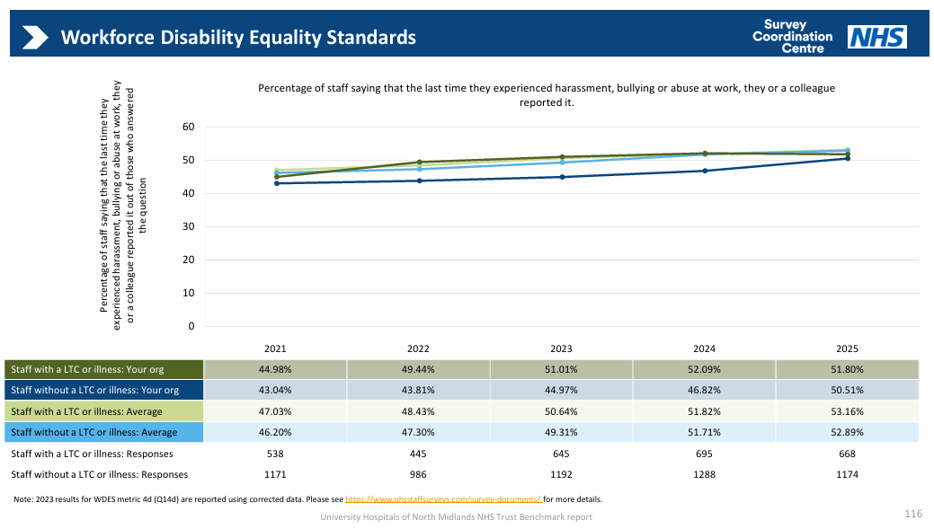
Whilst the percentage of colleagues with a disability or long term condition saying that they have reported their experience of harassment, bullying or abuse at work has slightly deteriorated, there has been a notable increase in the number of non-disabled colleagues reporting experiences.
It is positive to see the best performance since the WDES began in the percentage of colleagues with a long term condition (and those without) saying that they have reported experience of harassment, bullying or abuse at work. 51.01% is higher than our National Staff Survey peer comparator group average for colleagues with a long term condition.

The 2023 national WDES figure was 31.3% (taken from the 2022 National Staff Survey)
WDES Indicator 5
Percentage of staff who believe that the organisation provides equal opportunities for career progression or promotion

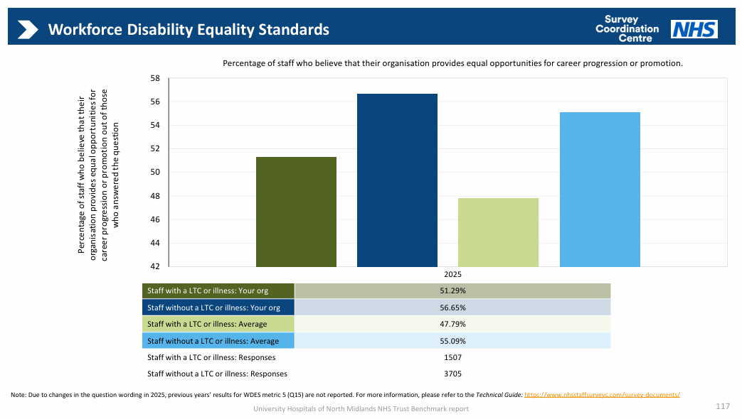
This indicator has slightly deteriorated but is in line with our National Staff Survey peer comparator group.

The 2023 WDES Data report average (from the 2022 NSS) was 52.1% for colleagues with a disability/LTC and 57.7% for colleagues without a disability/LTC.

This deterioration is also apparent in our Workforce Race Equality performance on the same indicator. The Trust’s work on inclusive talent management during 2024-25 will be designed to address inequity in recruitment and talent processes for all marginalised groups.

The wording of this question was changed for the 2025 national staff survey. Our performance for colleagues with a disability/LTC (and those without) is better than our NSS peer comparator group. The gap between disabled and non-disabled colleagues is also positively narrowing.

WDES Indicator 6
Percentage of staff who have felt pressure from their manager to come to work, despite not feeling well enough to perform their duties

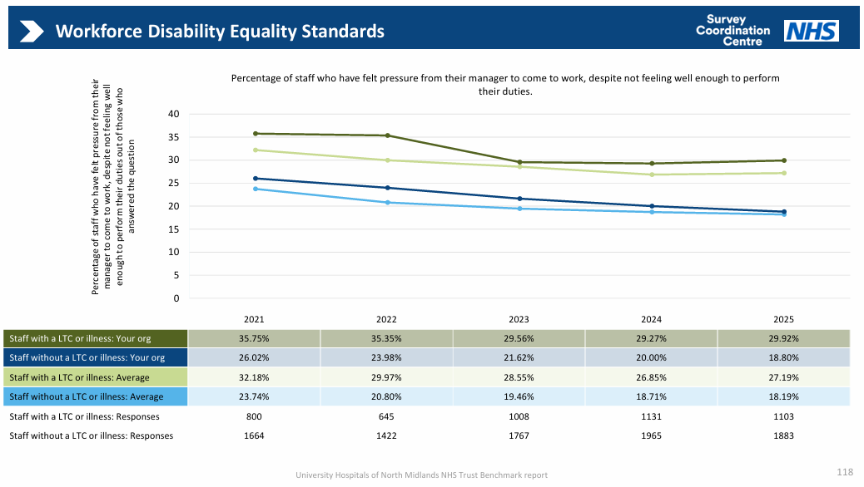
This year’s data shows a significant improvement for disabled colleague experience of feeling pressure from their manager to come to work despite not feeling well enough to perform their duties (known as presenteeism), with an improvement of 5.8%.

Our performance, which is our best ever for both colleagues with a disability/LTC and those without remains above the average for our NSS peer comparator group.

This year’s data shows a stable position for disabled colleague experience of feeling pressure from their manager to come to work despite not feeling well enough to perform their duties (known as presenteeism). The difference between the experiences of colleagues with a long term condition compared to those who do not, has deteriorated at 11%.

The performance is worse than the average for our NSS peer comparator group, and the national data from the 2025 WDES Report which shows that 25.3% of disabled colleagues felt presenteeism.

WDES Indicator 7
Percentage of staff satisfied with the extent to which the organisation values their work

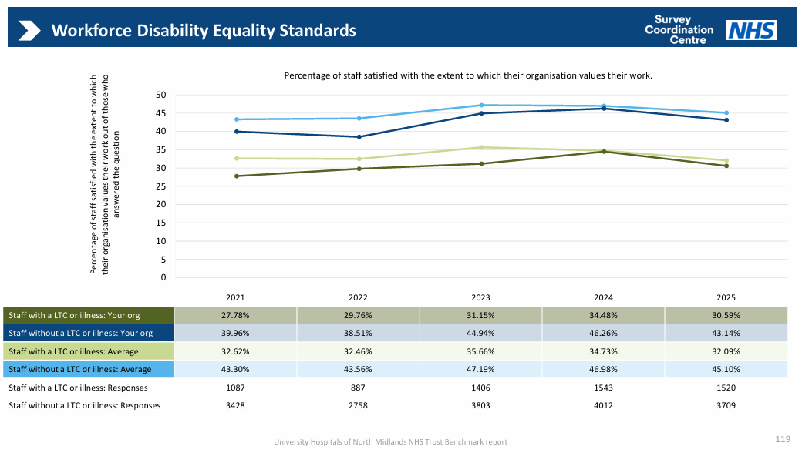
This indicator has improved on the previous year, and the third year of improvement for colleagues with a disability or long term condition.

During 2023 we launched the revised Personal Development Review with a focus on recognising trust values and inclusion and supporting colleagues to achieve their potential. The process also encourages colleagues to discuss any wellbeing support required.

Our data is below the comparator peer group average and the WDES national average (from the 2022 staff survey) of 35.2%

This indicator has deteriorated by nearly 4% on the previous year and also fallen for colleagues without a disability or long term condition. Our peer group averages have also deteriorated.

WDES Indicator 8
Percentage of staff with a long lasting health condition or illness saying the organisation has made reasonable adjustments to enable them to carry out their work

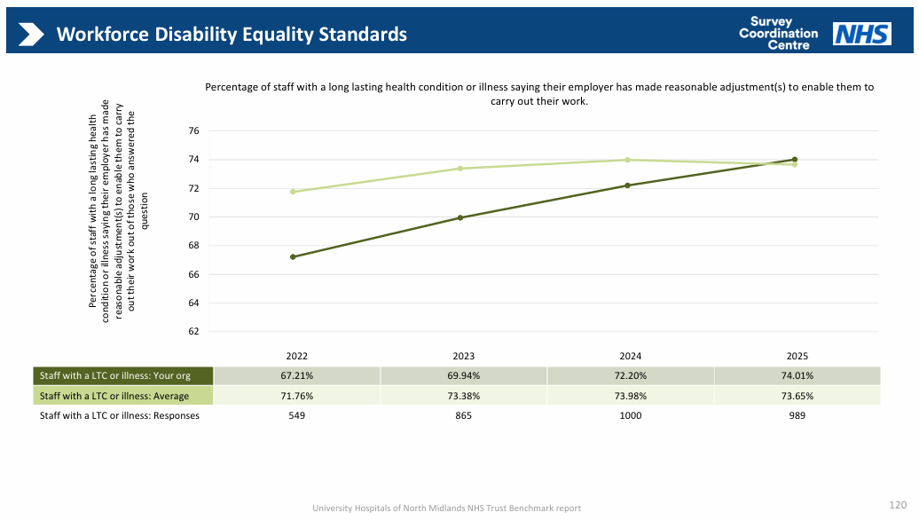
This metric has improved but is lower than our NSS peer comparator group and the national WDES average of 73.4%.

In November 2023 we introduced a new Reasonable Adjustments Policy, developed with our Disability and Long Term Conditions Staff Network. This was accompanied with two recorded webinars – one targeted at line managers and applying the policy and the second being a step by step guide to having a conversation to complete a Tailored Adjustments Plan.

This clear commitment from the organisation to the provision of reasonable adjustments will hopefully be reflected in an improved score for this indicator in the 2024 national staff survey.

This metric has improved by 1.8% and for the first time is better than our NSS comparator group (73.65%). The national WDES average was 75.3%.

WDES Indicator 9
Staff Engagement Score

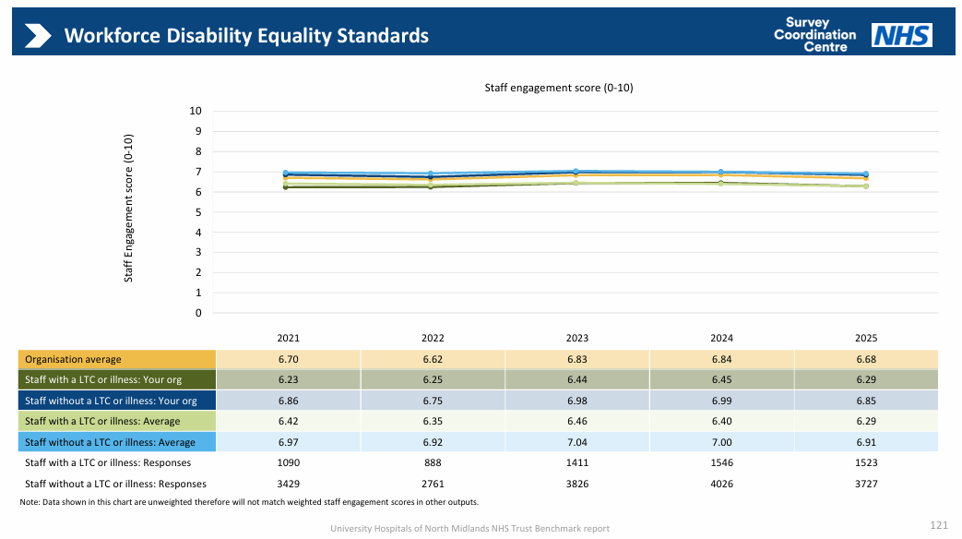
Whist this indicator has seen improvements for all colleagues compared to the previous two years, it is below our NSS peer comparator group, but in line with the WDES national average from the 2023 Data Report of 6.4 for colleagues with a long term condition and 6.9 for colleagues without a long term condition.

Whist this indicator has deteriorated for all colleagues, for colleagues with a disability/LTC our score matches our peer average at 6.29

WDES Indicator 10
Percentage difference between the organisations board voting membership and the overall workforce

Boards are expected to be broadly representative of their workforce. 6.25% of the UHNM board have a disability according to ESR, giving a percentage difference between the board and the overall workforce of -0.4%. The national average percentage difference between boards and their overall workforce in 2025 was +0.7.

Summary and Actions

The 2026 WDES demonstrates a mixed picture of progress and persistent inequality for disabled colleagues. There are encouraging signs of improvement in disability disclosure, recruitment outcomes, career progression perceptions and workplace adjustments, with several indicators performing at or above our peer benchmark levels. However, disabled colleagues continue to experience poorer workplace outcomes than non-disabled colleagues, particularly experiences of bullying and harassment, presenteeism, and feeling valued at work. The data suggests that while many of the organisation's systems and processes are improving, disabled colleagues are not yet experiencing equitable outcomes or day-to-day working experiences.

During the next 12 months we will take forward the following actions:

 | Reasonable Adjustments | Disability Career Progression | Presenteeism
Action | - Focus on neurodivergence awareness  - Targeted action in teams with poorer NSS satisfaction responses regarding workplace adjustments | - Monitor progression rates by disability status  - Increase support for disabled colleagues aspiring to senior roles  - Promote flexible working in senior roles | Improve manager understanding of:  - Recognising signs of presenteeism  - Understanding the impact of long-term conditions and fluctuating disabilities.  - Having supportive wellbeing conversations  - Understanding when a flexible approach to attendance management can be applied as a reasonable adjustment

