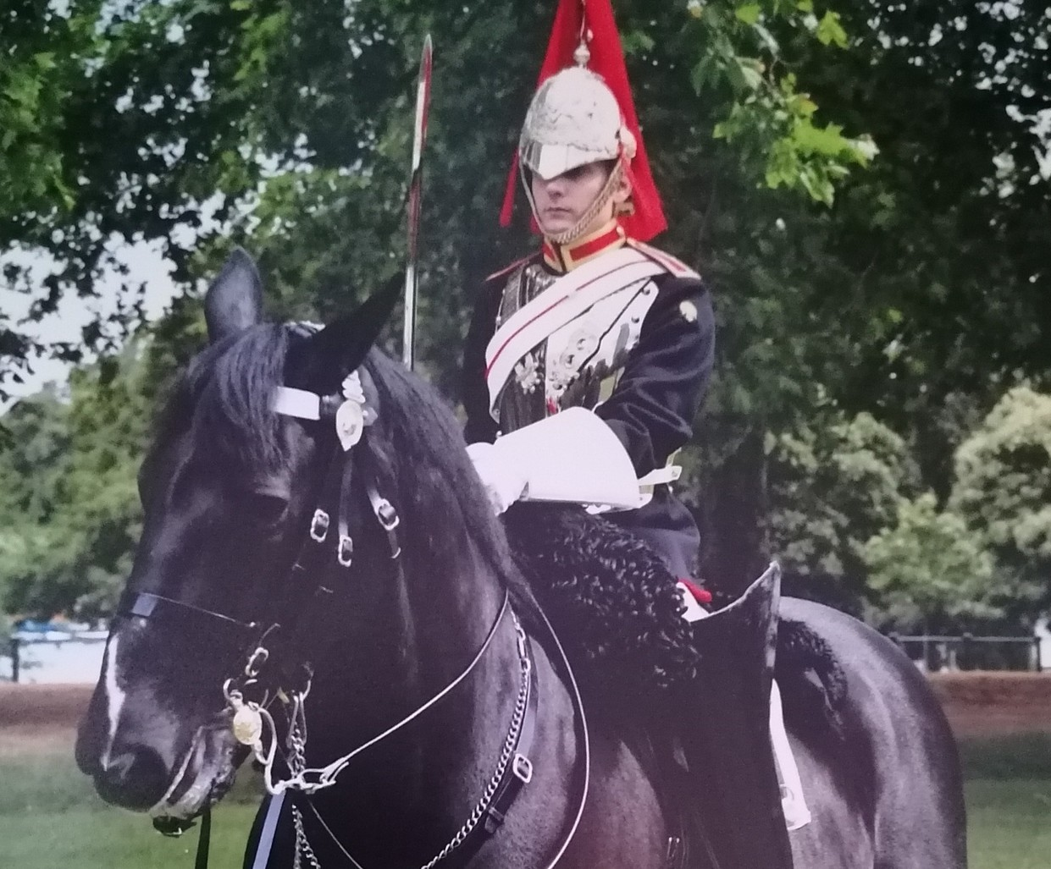Landau Training & Enterprise Centre, Waterside Drive, Stoke on Trent, ST3 3NW
REMEMBRANCE GARDEN PROJECT

We are inviting all veterans and their families to join us in a new project at our Waterside Drive site in Stoke-on-Trent.
We are delighted that Marc Goodwin has joined Landau to manage the project, a veteran of the Household Cavalry with service from 2006 to 2012.

Please join us on Saturday 21st August at 10am for a welcome event, coffee & a chat so that we can agree on plans together.
Our project will include planting vegetables & flowers to be enjoyed by you & your local community. We plan to create an informal garden including garden furniture using your building & carpentry skills, with a central meeting point featuring our "In Memoriam" metal sculpture as a focal point for Remembrance Day.
We look forward to seeing you and your families.

Please contact us on 01952 245015 quoting "Supporting Veterans"

