Questions to ask

When you go to the doctor or to a hospital

Easy read

Questions to ask

When you go to the doctor or to a hospital, it is important you
understand what they say to you.

Before you leave the doctor or hospital, make sure you know what they think might be wrong with you and what you need to do next.

You could say:

- “I would like to check that I understand what you said.” Then tell them what they have told you.

- “Can you explain it again, please? I still don’t understand.”

- “I would like to have a copy of any letters about me.”

1

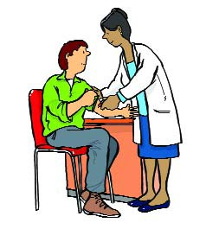If you need to have more tests, you could ask:

- “What are the tests for?“

- “How will I get the results?”

- “When will I get the results?”

- “Who do I ask if I don’t get the results?“

If you are going to have treatment, you could ask:

- “Are there other things you could do to make me better?“

- “What do you think would be best for me?”

- “Are there any side effects or risks?” Side effects
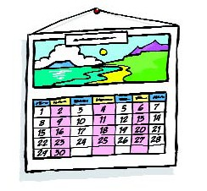are when a medicine or treatment does something to you that may make you feel bad.

- “How long will I need treatment for?”

3

- “How will I know if the treatment is working?”

- “How good is this treatment?”

- “What will happen if I don’t have any treatment?”

- “Is there anything I should stop doing which would help me to get better?”

- “Is there anything else I can do to help myself?”

If you want to know what
will happen next, you could ask:

- “What happens next?”

- “Should I come back and see you again?”

- “Who should I talk to if things get worse?“

- “Do you have any leaflets about my illness or treatment I could read?”

- “Where can I get more information?”

- “Is there a support group or other help I could get?”

Top tips

Some things to do before you go to the doctor or hospital

- 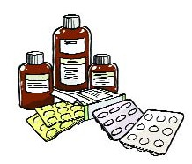Make a list of your most important questions. Or get someone else to write them down for you.

- Make a list or bring any medicines and pills that you take with you.

- Write down your symptoms.
Symptoms are the aches, pains or feelings you have that tell you that you are ill.

- Write down when your symptoms started and say what makes them better or worse.

- Ask your doctor or hospital for someone to support you if you want help at the doctor or hospital.

6

- Ask a friend or family member to come with you, if you like.

At the doctor or hospital

- Don’t be afraid to ask if you don’t understand. Say, “Can you say that again? I still don’t understand.”

- If you don’t understand any words, ask the doctor to explain them. You could ask the doctor to write down any difficult words so you can look them up later.

- Write things down, or ask a family member or friend to do this.

Before you leave the doctor or hospital

- Check that:

  - You have done everything on your list.

  - You know what should happen next, and when it should happen. Write it down.

Ask:

  - “Can I just check I understood what you said?”

  - “Who should I ask if I have any more problems or questions?”

Ask:

  - “Where can I get more information?”

  - “Are there any support groups that could
help me?”

  - “Are there any letters written about me? I would like
to see copies of these.”

After you leave the doctor or hospital

- Write down what you talked about and what happens next. Keep your notes.

- Book any tests that you can, and put the dates in your diary.

- If you do not hear quickly about your next appointment, ask “What is happening?”

- If you don’t get the results when you expect them, ask “Can I have the results of my tests?”

- If it is not clear, ask “What do the results of my tests mean?”

Remember, it is important that you understand what the doctors say to you, and what you must do to get better.

© Crown copyright 2007 280794 Jun07

