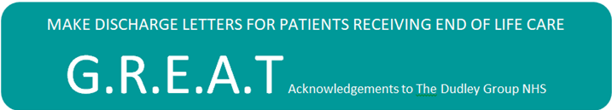 | Royal Stoke University Hospital  Macmillan Specialist Palliative Care Team  Room MO55 Outpatients 3  Newcastle Road  Stoke-on-Trent  Staffordshire  ST4 6QG  Tel: 01782 674029

Dear Community Colleague,
We have recently piloted the GREAT acronym in discharge letters for end of life/palliative care patients (poster attached) and we are writing to inform you that that we are now planning to roll this out across UHNM. GREAT was developed by The Dudley Group of Hospitals and has proved successful in improving communication between secondary and primary care and is now used in a number of hospitals across the UK.
GREAT stands for :
GSF - Should the patient be included on your GSF register?
Resuscitation status – Does the patient have a DNACPR form?
End of life medications – Have the end of life medications been prescribed for discharge?
Advance care planning – Has the patient communicated any preferences regarding their end of life care and do they have any advance care planning documents including a ReSPECT form?
Treatment escalation/limitation plan – Have any decisions been made regarding appropriateness of interventions such as future hospital admissions?
The hospital e-discharge letter sent to you may now include a specific Palliative Care heading which will include the GREAT information. The GREAT acronym does not appear on the patient’s letter. The GREAT information on the patient’s discharge letter should not be new to the patient, unless specified by the clinician. There is further information about the GREAT acronym and ReSPECT form on the UHNM website (need link). Please feel free to contact us if you would like any further information.
With kind regards,
Charmaine Butcher and Fiona Read
Hospital Specialist Palliative Care Nurses

