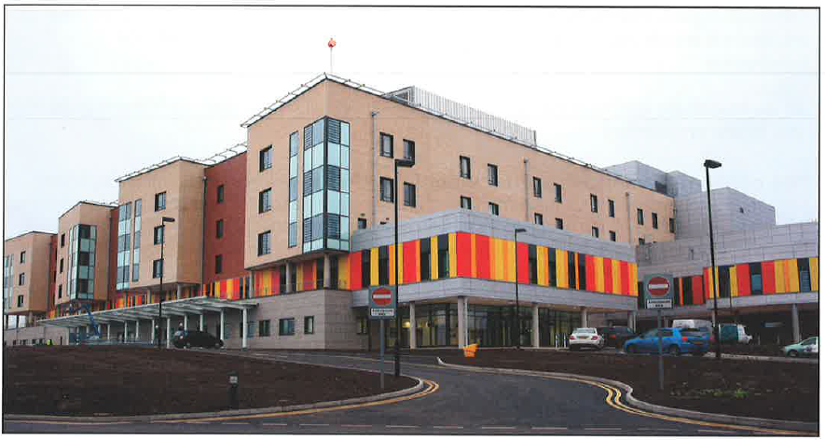

PATIENT PROCEDURE INFORMATION LEAFLET

ENDOSCOPIC ULTRASOUND
(EUS)

What is an EUS?
An Endoscopic Ultrasound (EUS) is a procedure which allows the Endoscopist to examine the lining and layers of the upper gastrointestinal tract, which includes the oesophagus (gullet), stomach, duodenum (first part of the small intestine that is connected to the stomach) and the surrounding areas and organs such as the pancreas and gallbladder.
It involves passing the endoscope (a long thin tube with an ultrasound probe at the tip) through your mouth, down the oesophagus and into your stomach and duodenum. The procedure is the same as for an upper gastrointestinal endoscopy which you may have already had, in EUS this is combined with high frequency sound waves, transmitted from the ultrasound probe at the tip of the endoscope. This allows a scan of the surrounding organs.

Why am I having an EUS?
Your doctor wants to find out if there is a reason for the symptoms you are having so that he can suggest treatment. It can be used to diagnose and treat:
- The size and nature of abnormal areas or lesions
- Gallstones
- Glands
- Biopsies (tissue samples)
- Whether further surgery is required

Are there any alternatives to the test?
Yes, a Computed Tomography (CT) scan but the investigation is less sensitive and small lesions/glands (less than 1cm) can be missed.

Are there any risks to the test?
The procedure is considered safe. Complications are rare but possible:
- Allergic reaction to the equipment, materials or medications. The Endoscopy team is trained to detect such reactions but it is important to tell them if you have any allergies or if you have reacted to any tests or drugs in the past.
- Bleeding can occur from a biopsy site. This usually stops on its own. Let the endoscopist know if you are on warfarin or other blood-thinning drugs. If you are on warfarin, then it is unlikely that a dilatation will be performed or a biopsy taken.
- Perforation, a tear in the intestinal wall (oesophagus, stomach, duodenum-small intestine). This can be made during the procedure and the risk is slightly raised if an abnormality such as narrowing or growth is encountered. If therapeutic treatment is performed such as stretching the narrowing, the possibility can be up to 1 in 10 procedures. If a hole is made, you will need to be admitted to hospital for further treatment which may include surgery. If you develop severe chest pain while at home, tell you r doctor straight away.
- Complications of sedation.
- Damage to teeth, crowns or bridges.
- Aspiration.
- You may also have a mild sore throat.
Before admission
Please remember no food for 6 hours before the test and clear fluids only until 2 hours before the test.
This is very important as we cannot do the test if you have eaten.

What should I expect?
- On arrival, report to the Reception desk in Endoscopy Unit. Your details will be checked and you will be asked to take a seat.
- A nurse will collect you and take a brief medical history from you, including a discussion of your current medication, discharge arrangements and the test itself. Please inform the nurse of any allergies. Please ask questions if you have any.
- You may be asked to wait a short while until you have the test.
- A Nurse or Endoscopist will ask you to sign the consent form making sure you understand the test.
- You do not need to get undressed, but you will need to take off your coat.
- The ward is a single sex area.

Is the procedure painful?
The procedure can be uncomfortable so you will be offered a sedative and a painkilling injection which is given through a plastic tube (cannula) inserted into the back of your hand or arm. This will make you more comfortable but it does not put you to sleep, however you may forget the procedure afterwards, and there are special aftercare requirements for 24hours after the procedure.

If you do not wish to have any of this option, please inform the nurse.

During the test
- You will be taken into the procedure room. In the room will be the Endoscopist and two nurses who will stay with you during the test.
- You will be made comfortable on your left side with your arm behind your back as you may be turned onto your stomach during the test.
- Oxygen will be given through a tube placed in your nostril and a probe placed on your finger will monitor your pulse and oxygen levels.
- A pad will be placed under your chin.
- A plastic mouth guard will be placed gently in your mouth.
- You will be given the sedative injection via a cannula normally in the back of the hand. This will make you feel relaxed and comfortable.
- The endoscope will be passed across the top of your tongue to the back of your throat. Try to breathe steadily and remain calm.
- Tissue samples can be taken and this is painless.
- If you get a lot of saliva in your mouth, the nurse will clear it using a suction tube.
- The endoscope is removed slowly taking some air out at the same time.
- The mouth guard will be removed and a tissue provided to wipe your mouth.
- You will be made comfortable
- You will be taken out to the ward area to recover.

When can I go home?
As you will be having a sedative, you will need to rest in the department for as long as necessary. We will only discharge you when you are safe to go home and you feel happy to do so.

If you have had sedation:

FOR 24 HRS YOU MUST NOT:
- Drive
- Operate machinery
- Drink alcohol
- Sign legal documents

How will I feel afterwards?
- Your throat may feel sore but will settle without treatment.
- You have been sedated so may feel tired and lethargic for the 24 hours so you should rest.
- You should be able to eat and drink as normal once the effects of the throat spray have worn off.

When will I know the results?
When you are fully awake, you will be told about the test and anything that has been done. We prefer a family member or friend to be present as you may forget what you have been told because of the medication you have had. If you object to a family member being present, please inform the nurses.
You will be given a discharge leaflet which includes aftercare, useful telephone numbers and information about your test.
The hospital Consultant responsible for your procedure will receive any biopsy results and will write to you or see you in Out- patients.
A copy of the report will also be sent to your GP.

The consent form
You will find a consent form with this information. This gives the Endoscopist a formal indication that you are agreeing to undergo the procedure as described. You keep a portion of the form as your record.
Please read the consent form and bring it with you to the appointment.

What if I decide not to have the test?
If you read this letter and decide not to have the test, then please ring the department to tell us and you should also discuss your decision with your GP or hospital Consultant.

Getting Here
Royal Stoke Hospital, Newcastle Road, Stoke-on-Trent, ST4 6QG.
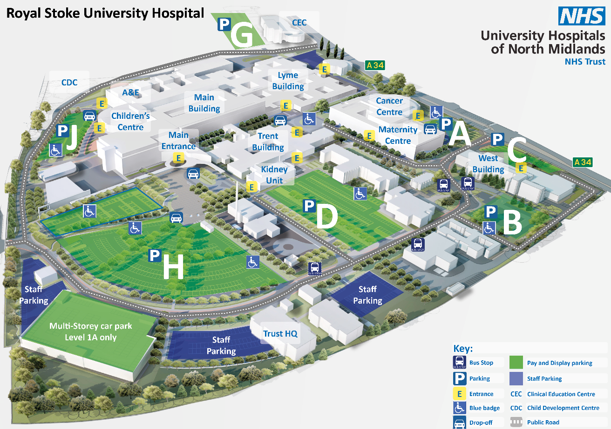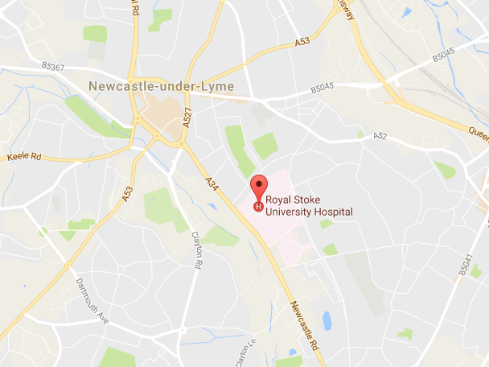
Please note car parking charges will apply.
There is a shuttle bus service from County to Royal Stoke at a charge of £5 return. Please call 01782 824232 to arrange a place on the bus.

